2026 CECO CALENDAR OF EVENTS

MAY
2nd WORK PARTY
3rd WORK PARTY
15TH ROD & GUN MEETING 7:00 p.m. Pavilion
16TH MEMBERSHIP MEETING 11:30 a.m. -
Pavilion
17th TRAP SHOOT
24th FLAG CEREMONY 11:00 a.m. Memorial Path
24TH KIDS FISHING TOURNAMENT
12:00-1:00

JUNE
20th BASS CATCH AND ENJOY DERBY! at 8:00 a.m. Shawnee.
Registration at 7:30 a.m.
20th CRAFT SHOW 10:00 a.m. pavilion
20TH BINGO 7:00 p.m. pavilion

JULY
18TH 9TH ANNUAL CECO FUN DAY
Children’s games at 1:00 p.m.
Young Adult games at 3:00 p.m.
Adult games at 4:00 p.m.
*Pot Luck Dinner at 6:00 p.m.
Music and Dancing at 8:00 p.m.

*FOOD Sign-up sheet posted at the lifeguard room

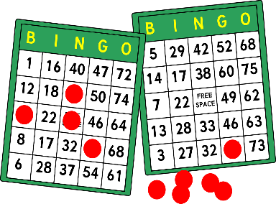
AUGUST
15th BINGO 7:00 p.m. -Pavilion

SEPTEMBER
5th EUCHRE TOURNAMENT
7:00 p.m. - Pavilion
18th ROD & GUN MEETING 7:00 p.m. -Pavilion
19th MEMERSHIP MEETING 11:30 a.m. – Pavilion
20th TRAP SHOOT 10:00 a.m.
26th 8TH ANNUAL TRUNK OR TREAT – Noon
At the Pavilion.

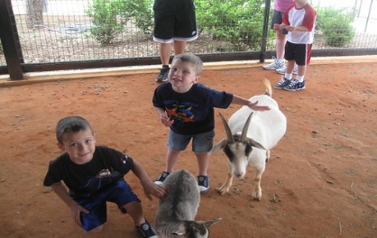
This Photo by Unknown Author is licensed under CC BY-SA

OCTOBER
3rd WORK PARTY
4th WORK PARTY

