Revised April 2026
RULES AND REGULATIONS
These Rules and Regulations are to be set by the CECO board with a majority vote.
- Members are responsible for the actions of their guests and must be on the property, with their guests, always. Guests are not to roam the property at random. Members will be allowed to have guests until such privileges are abused. At which time, restrictive measures will be added.
- No drinking or possession of any alcoholic beverages by an individual under the lawful drinking age of twenty-one will be allowed on CECO property.
- The use of abusive or profane language on the club premises will result in the eviction of any violators.
- Swimming will be allowed only in the beach area, between 8 a.m. - 10:00 p.m. when lifeguards are off duty swim at your own risk, within the first set or ropes.
b. Wading AT YOUR OWN RISK is allowed anywhere on lakes contiguous to the main lake from dawn until dusk EXCEPT: from the temporary boat parking area to the beach-from the fishing dock to the fishing dock boat ramp.
Wading means standing or sitting on the ground in the water. Swimming, floating, or otherwise supporting your body with something other than the ground is not wading and is NOT ALLOWED. Children under the age of 13 must wear a USCG approved life jacket and be supervised by an adult when wading.
- Keeping the grounds clean will be the responsibility of all members.
- No personal docks are not allowed.
- All firearms on CECO property must be properly stored, according to all State and Federal regulations. Concealed Carry (CCW) is not allowed on CECO property except for law enforcement.
- Any personal property left on the premises will not be the responsibility of the association.
- No buildings of any kind shall be erected on CECO property except by the association.
- Pets are not allowed in the beach or picnic area year-round.
- All owners of unlicensed motorized vehicles (ATV or UTV) are required to register these vehicles yearly and a certificate of insurance will be necessary for registration. Golf carts with lights and horns are permitted on existing roads and parking areas only and must be registered and insured. All drivers must be state licensed.
- Members must have their CECO number three inches in height on all of their equipment, such as, on the tongue of all trailers, tents and upper port (left side) rear of all boats.
- Only one guest car per membership on CECO property at any time. All vehicles will be identified with a CECO decal or CECO guest car pass upon entering the property. Members needing extra guest passes in advance of an event can get them from any Board Member up to 5 passes. More than 5 guest passes must be obtained from the President.
- No guests allowed on CECO property from 8 p.m. until 6 a.m. without the member or the member’s spouse.

- Car decals must be permanently affixed to the lower left-hand side of the windshield (driver’s side). All old CECO decals must be removed.
- No guest deer hunters except member’s family.
- Keys are not transferable. Lending keys to unauthorized persons will be subject to loss of membership.
- All equipment must be removed from the temporary holding area from October 15 to April 1.
- No fireworks of any kind are to be brought or used on CECO property.
- No guest boats or ATV’s/UTV/Golf carts allowed on CECO property.
Violations of any of the rules shall result in a penalty set forth by the board after an opportunity to be heard by the person or persons involved before the board of directors.
CAMPING RULES AND REGULATIONS
Due to the impossibility of covering all situations, COMMON SENSE AND COMMON COURTESTY are to be the RULE in all cases not covered in the following rules and regulations.
Numbered Camp Sites
No camp trailer may be parked in the numbered campsites for more than two (2) weeks.
- Trailer size is limited to forty (40) feet on all campsites. Members are to use discretion when they park their trailer and are not to make any alterations to the area. Campers, trailers, or motor homes may be allowed in the designated area after application stating size and description is made to the board of directors. Permission will be granted at the discretion of the board of directors.
- All campers must register in and out at the designated area.
- Campers may have a campsite for no more than two (2) weeks at a time. All equipment must be removed from the campsite at the end of that period and cannot go back on that campsite for a period of three (3) weeks. Campers must not leave campsite unoccupied for more than four consecutive days.
- Pets are allowed in numbered campsites. When on the property, these pets must be properly controlled, tied, and have all necessary shots. Proper control means no excessive barking, clean up pet waste and must always be tied or leashed. No guest dogs allowed.
- Guest campers must use the same numbered campsite as the member. Only one (1) guest tent or trailer is allowed in addition to member’s equipment. Member must always be present when their guest is on the property.
- All campsites must be left clean. Pet waste must be cleaned up and disposed in dumpsters.
- Reservations for campsites will not be accepted.
- No septic system of any kind can be installed in any campsite.

Unnumbered Camp Sites
- Unnumbered campsites are regulated by the CECO Board and must be held by a certificate holder.
- The campsite may remain in the family if there are other certificate holding family members and may be passed to another certificate holding member at the discretion of the board of directors.
- An Associate Member may not hold an unnumbered campsite.
- Trailer size is limited to 40 feet.
- Certified Park Models must be constructed to meet NFPA 1192 standards and have a RVIA certification. All units must be equipped with both fresh and wastewater holding tanks and are required to be pre-approved by the Board of Directors before making a purchase. Other restrictions apply.
- Campsites are not to be seen from the Beach house veranda. Members are to use discretion when they park their camper. Camper location and major site alterations must be approved by the CECO Board Camping Leader.
- Pets are allowed on campsites. When on the property, pets must be properly controlled and have all necessary shots.
- Guest campers must use the same campsite as the member. Guest tents or trailers are allowed in addition to member’s equipment. Member must be present at all times when their guest is on the property.
- The certificate holding member of an unnumbered campsite must clean up the site by May 1 for the following season. The site must be maintained year-round including.
- The appearance of their camper and camping equipment.
- All campers must be movable.
- A minimum of five (5) separate overnight stays per year. In addition, the site holder or a family member must attend at least one day of the spring or fall work parties.
- Only non-phosphate fertilizers are allowed for treatment to prevent weed buildup of the lakes.
- All campsites must be left clean. Pet wastes must be cleaned up and disposed in dumpsters.
- No septic system of any kind can be installed in any campsite.
- A storage shed with outside dimensions no larger than 7’ x 7’ x 7’ will be allowed on unnumbered campsites after construction plans are submitted to the board of directors and approved.
- Outhouses will be regulated by the main CECO Board and are available for use by all members.
- If any of the above is in violation and is the decision of the board, the occupant must vacate the campsite. They must remove their camper and all camping equipment from CECO property.

Procedures to obtain a unnumbered camp site
- A campsite may pass on to a certificate holding family member, or along with the certificate in the event of the original member becoming a SA member or upon their death.
- A certificate holding member may submit their name and membership number to a CECO Board member to be added to the waiting list for a permanent camp site in addition, to remain on the list, must attend one day of the spring or fall workdays each year.
- A certificate holding member may petition the CECO Board to build a new unnumbered campsite by submitting a proposal including a drawing. If approved, all cost will be assumed by the member. The plan must be approved by a majority of the Board members.

GROUP CAMPING REGULATIONS
- Organized youth groups may be granted permission to use our grounds during authorized periods providing the following rules are followed:
- The CECO board of directors receives requests at least thirty (30) days prior to camping date.
- A maximum of eighteen (18) youths with a counselor with each six (6) for a maximum total of twenty-one (21) in the group at any one time.
- Counselors must always have direct supervision over the activities. Guest youths must not be free to roam at random.
- Guest camping will be restricted to authorized area and will be limited to a maximum of seventy-two (72) hours camp time.
- All Groups must carry proper liability insurance.

GROUP RESERVATIONS
Groups may be granted permission to use our facilities with approval of the CECO Board.

BOATING RULES
All USCG and Illinois Boating Laws must be followed including the following:

Who May Operate a Vessel
Persons born on or after January 1, 1998, may operate a vessel powered by a motor only if they have a valid Boating Safety Certificate accepted by the Department of Natural Resources.
Persons under the age of 10 may not operate any motorized vessel.
Persons at least 10 years old but less than 12 years old may operate a motorized vessel only if they are accompanied by an adult.
Persons at least 12 years old but less than 18 years old may operate a motorized vessel if: • They complete a boating safety course and possess a Boating Safety Certificate.

Personal Flotation Devices
All vessels must have at least one U.S. Coast Guard (USCG)–approved wearable life jacket, for each person on board or being towed. All vessels 16 feet or longer, except canoes and kayaks, also must carry one USCG–approved throw able PFD. All children under the age of 13 must wear a life jacket on all vessels when underway and properly sized.

Fire Extinguishers
All vessels equipped with an internal combustion engine operating on CECO waters are required to have at a USCG–approved fire extinguisher on board

Sound-Producing Devices
On CECO waters, all motorized vessels must have a mouth-, hand-, or power-operated whistle or other device.

Navigation Lights
The required navigation lights must be displayed between sunset and sunrise and during periods of restricted visibility.

Diver-Down Flags
A rectangular red flag, at least 12 inches high by 15 inches wide, with a white diagonal strip is required.

Requirements for Towing Skiers
When a vessel is pulling a person on water skis, wake boards, knee boards and tubes the operator must have a competent person on board to act as a spotter. A person may not be towed from a half-hour after sunset to a half-hour before sunrise.

The Skier-Towing Flag
Vessels towing persons on water skis or other devices must display a skier-towing flag from the highest point around the vessel’s helm so that it is visible from all directions at all times while a person is in the water preparing to be towed, while the person is being towed, and until the person has re-entered the vessel. The flag may not be used for any other purpose. The flag must be bright orange and at least 12” x 12” in size.

CECO SPECIFIC BOATING RULES AND REGULATIONS
- ABSOLUTELY NO GUEST BOATS OF ANY KIND ARE ALLOWED ON CECO PROPERTY.
- The boat patrol has the power to remove any boats from CECO water for violation of the boating rules.
- The U.S. Coast Guard “Rules and Regulation’s” are in effect for all boats.
- A no wake policy will be enforced after dusk for the entire lake, and at all times in the no wake zone area as marked.
- Sitting on the gunwales is not permitted. No standing in kayaks or canoes is permitted. Standing in a moving boat is permitted when the boat is moving in at no wake speed. No sitting on front of pontoon with feet in water when boat is in motion.
- The pilot of any boat over 10 h.p. must be at least sixteen years of age, unless accompanied by an adult.
- Keep to the starboard at all times. To retrieve a downed skier, tuber, or kneeboarder make two left turns and circle back to the individual.
- Keep to the starboard of all buoys.
- Approved sound device shall be used any time entering or exiting channel between main lake and Piqua Bay and anytime when approaching area where main lake meets channel that runs parallel with boat ramp.
- When ready to take off from boat dock with skier, tuber, or kneeboarder, a boat coming towards you pulling someone has the right of way. Wait until it is safe to pull out.
- Keep a safe distance between the boat pulling skiers or tubers. Safety spotters are required when skiing, tubing, or knee boarding.
- As per State Law a 12 x 12 orange flag must be displayed at the highest point on the boat while pulling skiers or tubers.
- Piqua channel is a no wake zone. Pulling tubers, kneeboarders or skiers through channel between main lake and Piqua Bay is prohibited. However, tubing and knee boarding are allowed in Piqua Bay.
- Pulling skiers, tubers, or kneeboarders into boat parking area or south channel that runs parallel to boat ramp or north channel past the beach is prohibited.
- When dropping off skiers, tubers, or kneeboarders at boat dock, continue to far side of lake to pull rope, tubes, or kneeboards into the boat.
- Power boats must stay clear of the swimming area and maintain trolling speed in no wake zone past the blue barrels near this area.
- Excessive speeds and all horseplay are prohibited.
- The number of boats on the water may be restricted by the boat patrol, if necessary.
- Associate members will be requested to remove their boats from the water when the conditions warrant it for safety, due to the lake being overcrowded. The decision to remove boats from the water will be determined by the CECO board members or the boating committee and is final.
- Children twelve years of age or younger or known non-swimmers must wear life preservers while in a boat.
- The maximum length of a pontoon boat is 20.6 feet with a 90 h.p.The maximum length of all other boats (ski and/or fishing) is 19 feet with a 150 h.p. inboard/outboard motor. No skiing, towing or tubing from pontoon boats.
- Kayaks and canoes allowed in all areas except the swimming/beach area and must remain in nearshore zone. Life jacket rules apply.
- No water scooters, wind surfers, jet skis, ski chairs, paddleboards or sailboats are allowed on CECO water.
- All boat owners are to register their boat yearly. A certificate of insurance will be necessary for registration.
- NEW BOATERS WILL BE REQUIRED TO REVIEW BOATING RULES WITH THE BOATING COMMITTEE BEFORE A DECAL IS ISSUED.
- CECO decal and membership number are to be located on the upper port (left) side rear of boat. All lettering must be 3” in height.
- Boaters are not allowed to use the fishing dock to pick up or drop off riders. It is to unstable for that use.
- COMMON SENSE-COURTESY-SAFETY considerations shall prevail, always. (Power boaters give fishermen a Break) (Fishermen—do not park in middle of main lake during busy hours.)
ATTENTION: The State Conservation Department will have a game warden in our area periodically and all boats will be subject to inspection.
BEACH RULES
- No food or drink on the beach or in the water.
- No horseplay or pushing off the raft. do not try to sink the raft. no swimming under the raft.
- No throwing rocks or sand.
- No smoking on the beach.
- No flotation devices past the first set of ropes.
- No hanging on the ropes.
- No pets allowed on the beach or in the picnic area.
- Breaks are called every hour.
- Lifeguard breaks start after the last person is out of the water.
- Breaks are 20 minutes. No one is to be in the water during break.
- Swimming is allowed only in the designated swim area.
- Children under the age of 14 must be accompanied by an adult.
- No fires on the beach.
- Everyone is to clear the beach for 30 minutes if you see lightning or hear thunder. which resets every time you see lightning or hear thunder.
- Lifeguard hours are 10:00 a.m. – 6:00 p.m. May-June. 10:00 a.m. – 8:00 p.m. July/August/September.
- Swimming at your own risk is allowed from 8–10 a.m. and 8–10:00 p.m., within the first set of ropes.

SCUBA DIVING – SKIN DIVING – SPEAR FISHING
- All divers must be certified.
- Divers are required to wear a buoyancy compensator or some type of buoyancy or floatation vest.
- The buddy system is to be used, two (2) down and one (1) in boat. A buoy with a flag is to be in the water.
- Stay clear of boat channels and boat turn around areas and out of the way of powerboats.
- No air tanks allowed in the swimming area unless authorized by the board of directors.
- Skin diving with a snorkel in the swimming area only.
- Spear fishing is allowed outside of the swimming area. Only rough fish is to be taken during this particular season.

DEER HUNTING RULES
- All state of Illinois hunting regulations will be in effect for all hunters.
- Hunting and fishing rules and regulations maintained by the CECO Rod and Gun Club Board with CECO Board approval shall be in for

MEASURING THE LENGTH OF THE CAMPING TRAILER
TRAILER SIZE IS LIMMITEDTO 40 FOOT.
ALL TRAILERS ARE MEASURED ALONG A STRAIGHT LINE FROM THE FRONT OF THE INCLOUSURE TO THE BACK. THE TOUNG AND REAR BUMPER ARE NOT INCLUDED IN THIS MEASUREMENT.
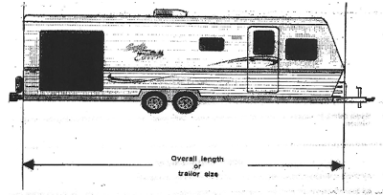

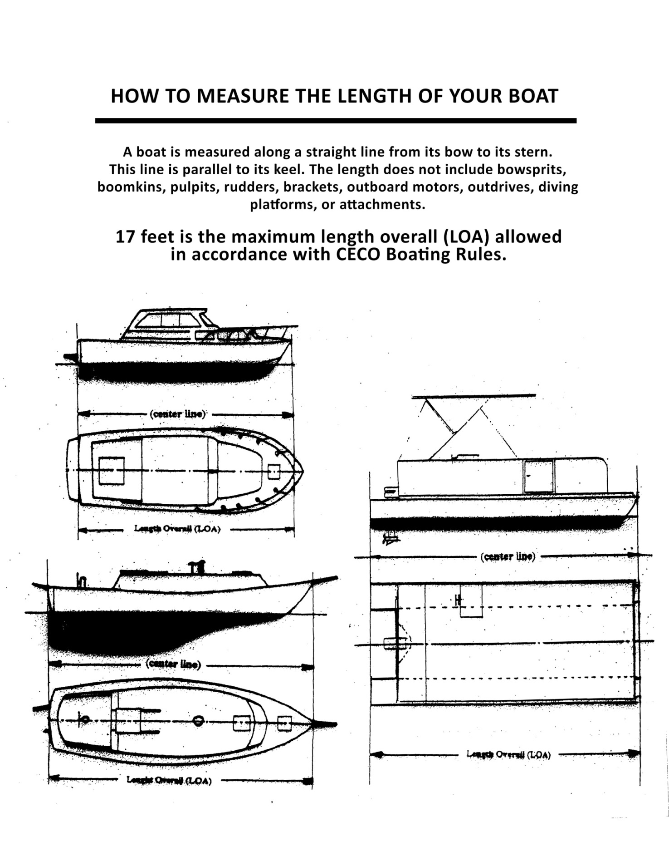
20’ 6” pontoon boats
19’ ski and/or fishing boats

ORDER OF BUSINESS
- OPENING
- READING OF MINUTES OF PREVIOUS MEETING
- COMMUNICATION AND BILLS
- REPORTS OF BOARD AND STANDING COMMITTEES
- REPORTS OF SPECIAL COMMITTEES
- UNFINISHED BUSINESS
- NEW BUSINESS (NOMINATING AND ELECTION OF OFFICERS)
- TREASURER’S REPORT
- CLOSING

CECO PRESIDENTS
JAMES KINSLEY 1959 – 1960 – 1961
EDWARD LEGAN 1962
RUSSELL BENNETT 1963 – 1964 – 1965
JAMES MISEWICZ 1966 – 1967 – 1968 – 1969
DONOVAN CARLSON 1970
MARVIN OLSON 1971
RICHARD SCOTT 1972 – 1973
DONOVAN CARLSON 1974 – 1975
ROBERT ERREK 1976 – 1977 – 1978
RICHARD SCOTT 1979 – 1980 – 1981 – 1982 – 1983 – 1984 – 1985 – 1986 – 1987 – 1988 – 1989 – 1990 – 1991 – 1992
FRANK PLUTH 1993 – 1994 – 1995 – 1996 – 1997 – 1998 – 1999 – 2000 – 2001 – 2002 – 2003 – 2004 – 2005 – 2006 – 2007 – 2008 – 2009 – 2010 – 2011 – 2012 – 2013 – 2014 – 2015 – 2016 – 2017 – 2018 – 2019 – 2020 – 2021 - 2022 – 2023 – 2024 – 2025 - 2026

